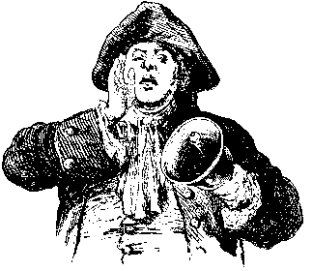
HERE YE!! HERE YE!! COME ONE!! COME ALL!!
THE SOMERSET COUNTY CULTURAL & HERITAGE COMMISSION WANTS YOU!
The Cultural & Heritage Commission is conducting an Assessment of Somerset County’s visual and performing arts, history and preservation resources.
We need YOU to have a voice in this important process.
You are invited to attend a Public Forum on Tuesday, August 13, 2013 at 40 N. Bridge St., Somerville. Choose your most convenient time: 10:00-12:00 or 2:00-4:00 pm, or 6:30-8:30 pm
The project definition of culture relates to visual and performing arts, history, historic preservation, folk and ethnic arts, literature and media as presented by arts and history/preservation organizations directly or indirectly by other sectors such as schools, social service and healthcare agencies, businesses and other non-traditional venues.
The data gained from this assessment will inform the objectives of a Five Year Strategic Plan for the Somerset County Cultural & Heritage Commission. Please RSVP to Cathy at 908-231-7021
Your responses will provide key information to ensure that SCC&HC’s future direction
derives from expressed needs, observations and feedback from YOU, the county-wide cultural community.
We need your thoughts and ideas to make Somerset County all it can be. All ages welcome.

